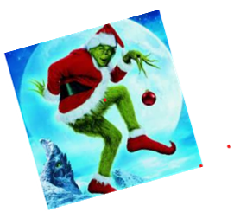

Easter Egg Hunts!!

Lot's of Fun!

BBQ's!

*Read all about it!*

Hello Rolling Forest!!!

Annual Events are happening and being planned in our neighborhood! Please see your “Year at a Glance” Calanders for event dates and details.

Are you interested in being part of “The Rolling Forest Social Committee”?

We have had great ideas shared about beginning annual activities for the Rolling Forest Neighborhood. We have decided it would be a great idea to pull together a group of energetic home/property owners to become part of that group and to help coordinate these activities. I am recruiting those that are interested and would like to help coordinate our events!

Some of those ideas are listed below. Other Ideas are always welcome!

* Member Dinner before each HOA meeting
  + Currently happening at face to face meetings
* Rolling Forest Annual BBQ
  + Currently scheduled in October of each year
* Annual Neighborhood Garage Sale
  + Currently scheduled for October of each year
* Rolling forest Annual Easter Egg Hunt
  + Currently scheduled for April 2020
* Annual “Christmas in the Forest” Event

Ginger Christopher – 281-705 3690

Kim Moeller – 281-961-7630